FREE Conference Save the Date:
“Mind, Body & Spirit Makes YOU Whole”

When: Saturday, March 18, 2023
This is a great conference for you!
Time: 10:00am-3pm Doors open at 9am
Where: SARC Office: 6203 San Ignacio Ave Unit 200 San Jose, CA, 95119

You MUST register no later than Saturday, March 11th to attend. NO onsite registration.! Max #75 Deaf Plus Consumers and plus 1.

ASL,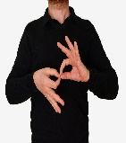CDI Interpreters and CART
This Photo by Unknown Author is licensed under CC BY-SA
Free backpack with goodies, light snacks, lunch, Resource Faire, and door prizes included!
https://sanandreasregional.seamlessdocs.com/f/deaf_plus_registration

Any questions, contact Evette Ybarra, at deafplusconference31823@sarc.org

