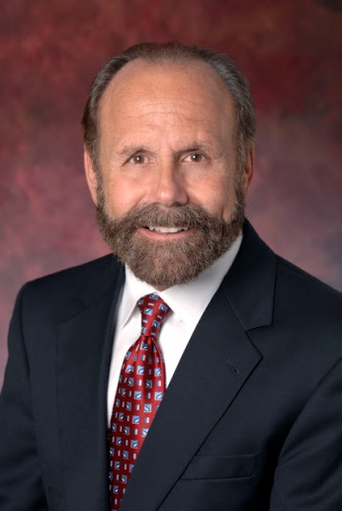
Jerry Hill was elected to the California Senate in November 2012 and took his oath in office in the state Capitol on December 3, 2012.

Senator Hill joined the state Legislature’s upper house with a strong track record of leadership and public service as an elected official. He was the mayor of the city of San Mateo, he served on the San Mateo County Board of Supervisors and he was a member of the state Assembly. While on the Board of Supervisors, he was involved in a diverse array of issues from health and safety protections for children, families and seniors, to improvement of schools, the environment roads and public works.

Taking office in the Assembly in 2008, he quickly established himself as a thoughtful and dynamic state lawmaker. He concluded his fourth year as an Assemblymember in November 2012. That year, 18 of the bills he authored were signed into law by Governor Jerry Brown – that was more than any other state lawmaker in 2012. His legislation included bills on pipeline safety, crackdowns on underage drinking on party buses and on retailers who sell tobacco to minors, foster family home protections and bills that make more information available to parents and guardians about child safety seats.

On December 3, 2012, the same day he was sworn into office, Senator Hill co-authored legislation that would make it easier for voters to approve school parcel taxes. The education reform legislation, called state Senate Constitutional Amendment 3, would allow local school districts, community college districts and county offices of education to approve a local parcel tax with the same 55 percent vote required for local school bonds used for capital expenses. Currently a two-thirds vote is required to approve school parcel taxes.

The senator also is a co-sponsor of the California DISCLOSE Act, which would require that the top three funders of political ads be clearly identified on the ads themselves and on the campaign’s website.

In addition, Senator Hill has proposed bills to improve the accountability of the state board that regulates utilities in California and to prevent repeat drunk drivers from driving drunk yet again.

He serves as the chair of the Senate's Democratic Caucus, the Environmental Quality Committee and the Energy, Utilities and Communications Committee's Subcommittee on Gas and Electric Infrastructure Safety. He also is a member of several other high-profile Senate committees including Appropriations; the Banking and Financial Institutions Committee; Business, Professions and Economic Development; the Joint Committee on Rules; the Select Committee on Emerging Technology: Biotechnology and Green Energy Jobs; the Select Committee on Passenger Rail and the Select Committee on Procurement.

Senator Hill represents the 13th Senate District in the California Legislature. The district includes the cities of Atherton, Belmont, Brisbane, Burlingame, East Palo Alto, Foster City, Half Moon Bay, Hillsborough, Los Altos, Los Altos Hills, Menlo Park, Millbrae, Mountain View, Pacifica, Palo Alto, Portola Valley, Redwood City, San Bruno, San Carlos, San Mateo, South San Francisco, Sunnyvale, Woodside and parts of unincorporated San Mateo County and unincorporated Santa Clara County.

Jerry Hill grew up in the Bay Area helping his father run his small business. Jerry still owns that business, which provides jobs to local residents. He attended public schools, graduated from UC Berkeley and has a teaching credential from San Francisco State University. He and his wife live in San Mateo.

