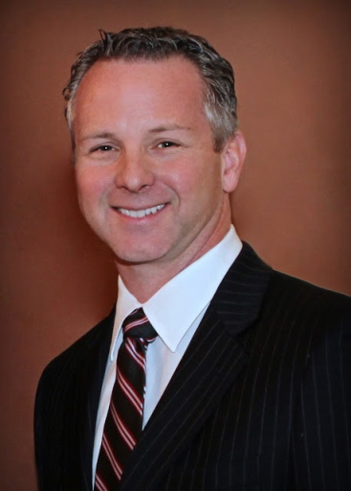
In November 2010, Ceres small-business owner Anthony Cannella was elected to represent the 12th District in the California State Senate.

Anthony currently serves as vice chairman of the Transportation and Housing Committee and Agriculture Committee. He is also a member of the Senate Rules Committee, Senate Energy, Utilities and Communications Committee and the Joint Legislative Audit Committee.

During his first term in the State Senate, Anthony helped enact reforms that will create new jobs, make neighborhoods safer, and increase funding for local schools by up to $2700 per student.

As vice-chairman of the Agriculture Committee, Anthony authored a measure to build new water storage facilities so farms will always have the water they need to keep our people working. Anthony also authored a measure that would fund efforts to clean up our drinking water.

An independent-minded legislator who will work across party lines to help improve the lives of those he represents, Anthony used his skills as a trained engineer to save tax dollars and cut government waste.

Prior to his election to the State Senate, Anthony served on the Ceres City Council and was twice elected mayor of that city. Under his leadership, the City of Ceres repeatedly produced balanced budgets, and built financial reserves exceeding twenty-five percent of its annual budget by cutting costs, and streamlined decision-making to make government more efficient.

Raised with an appreciation for public service that he learned from his father, former Assemblyman Sal Cannella, Anthony is a lifelong Central Valley resident.

Anthony is a civil engineer, and has founded two successful engineering businesses.

Anthony and his wife Julie have four children.

