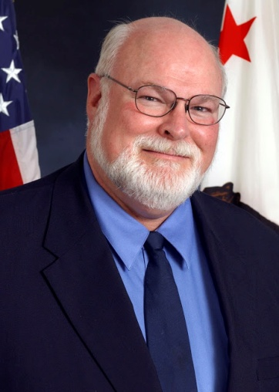
Jim Beall brings a lifetime of experience and understanding in government efficiency, transportation, and human services to the State Senate.

In three decades of public service – first as a San Jose City Councilman, then as a Santa Clara County Supervisor, and an Assembly member -- Jim Beall has left his mark across Silicon Valley.

He spurred the construction of Highways 85 and 87; fought to bring BART to San Jose; and authored bills to ease financing for seismic upgrades for our hospitals and also to grow California’s solar industry. This has meant thousands of good jobs for working families.

He is known throughout California for his legislation to help foster care children, low-income families, and people with disabilities.

And he has made a lasting difference in the lives of over 100,000 local youngsters by leading the drive to create the Children’s Health Initiative to ensure that every child in Santa Clara County can be covered by health insurance.

Beall plans to continue to help the people of Silicon Valley for years to come.

